Department of Photography App

CS F212

BITS Pilani

Apr 17, 2024

**1.1. Project Description:**

The Department of Photography App aims to aid in the effective collection, storage, and efficient distribution of photos taken of students by members of the Department of Photography. The Department of Photography is a team of 25 members that click an average of 3 lakh pictures over the course of each fest.

The system consists of a front-end user interface and a back-end database system to keep track of photos taken of students during fests, snaps, and other events. The database system will store information about students, like their hostel rooms, club and department memberships, authorisations, and dues for photos. The user interface will allow for easy access to stored information, allowing quick distribution of photos by Department of Photography members, easy viewing of snaps and dues by students, and effortless altering of club/department members by coordinators.

**1.2. Features**

The system will demonstrate the following features:

1. Storing and fetching student information

This system stores the names, BITS IDs, hostel rooms, room numbers, and email addresses, which are derived from the BITS IDs through an SQL query.

1. Viewing photographs

A student can view all the photographs they are featured in in one place through an SQL query. A student is also allowed to view the snapshots of the clubs and/or departments they are a member of. A snapshot is categorized as a club or department picture at the time of entering the photograph in the database.

1. Generating bills

Each student will receive a bill, generated by calculating the sum of costs from each photograph they have been tagged in, through a simple query.

1. Managing access

Department of Photography members (admin members) get full access to the database for editing and viewing of records. They will be able to see a Camera Log and Photo Log through the Control Desk.

1. Tagging photographs

Each photograph will be “tagged” with the BITS ID of the students present in the picture, ensuring that the student can view their photographs. This is also to ensure that due collection and distribution can be easily managed. Tagging can be done only by the admin members.

1. Control Desk

The system will also log Department of Photography members’ work, such as who is currently working, with which camera, and on which roll. This control desk will be accessible to the admin members, who will be able to see two lists. The first will be a camera list containing a list of every camera and the most recent photograph clicked with the camera, alongside details of the timestamp at which it was last used, and the clicker’s ID. The second will be a list of all the photographs taken by the Department of Photography members, including photo_id, clicker_id, detailer_id, date_time, roll_no, frame_no, file_address, and camera_id. The admin members will be able to access the tagging screen for every photograph individually.

1. Special access for club/department heads

A student will be able to access the records for whichever club or department they are a coordinator of. Coordinators of clubs and departments will have the authority to add and remove members from their respective clubs/departments.

**1.3. E-R Model**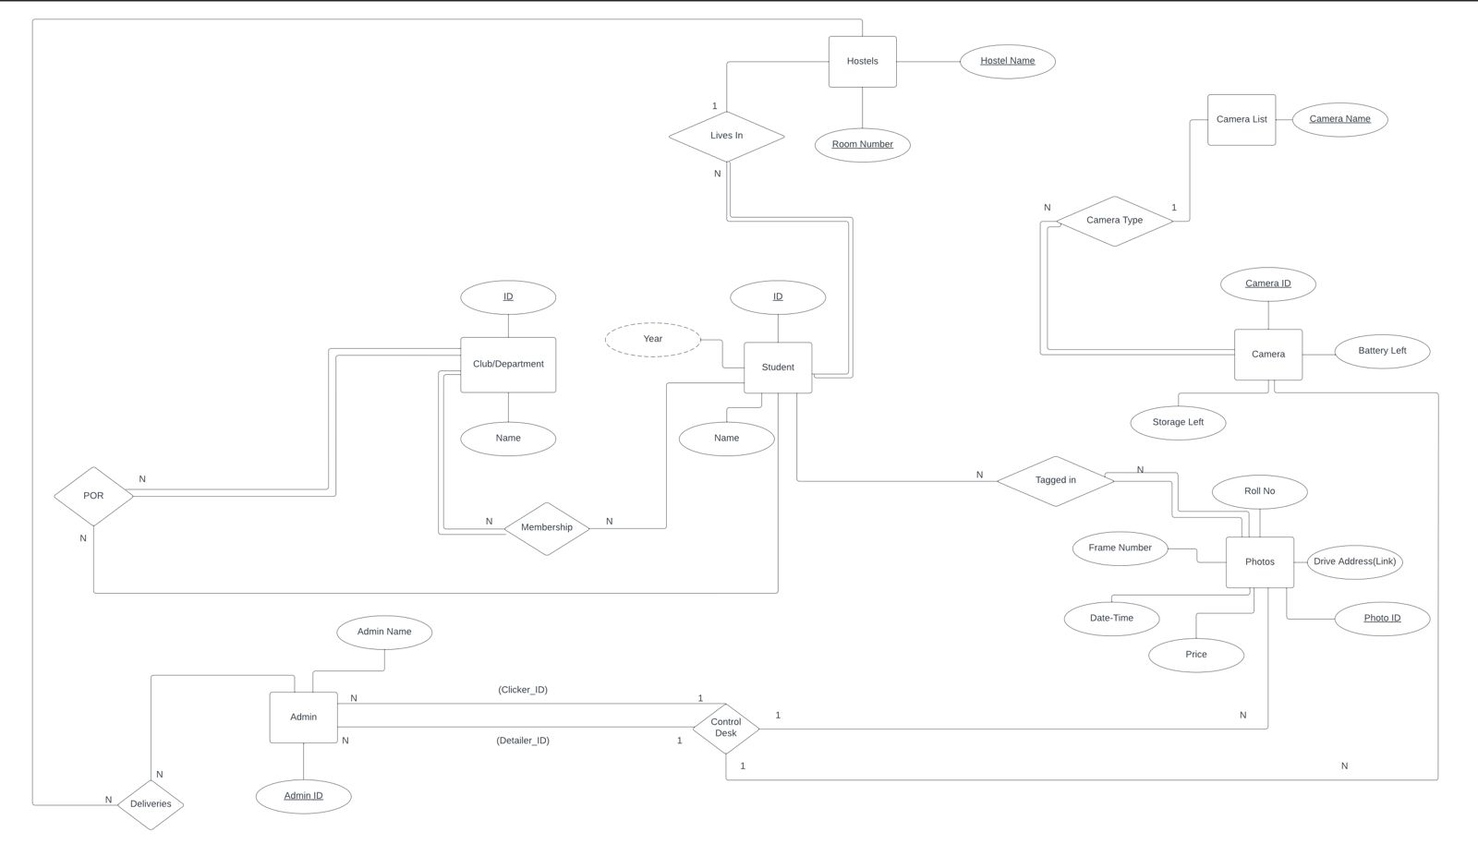

**1.4. Relational Model**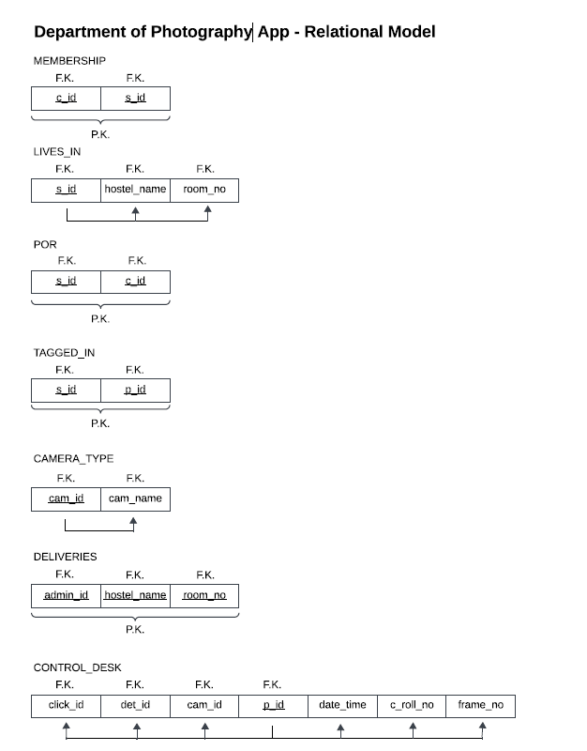

**1.5. Technical Details**

Screenshots of tables:

ADMIN

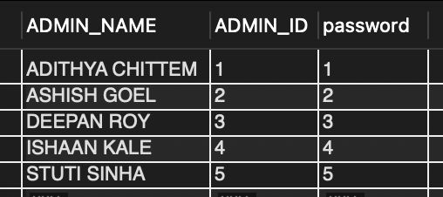

CAMERA_LIST

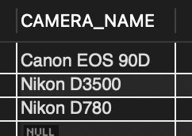

CAMERA_TYPE

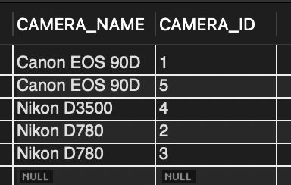

CAMERA

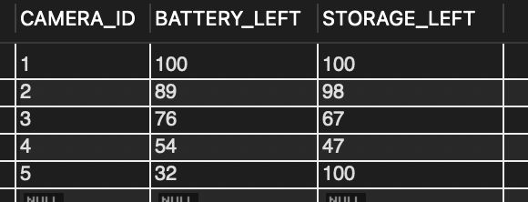

CONTROL_DESK

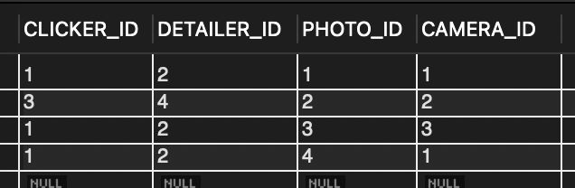

LIVES_IN

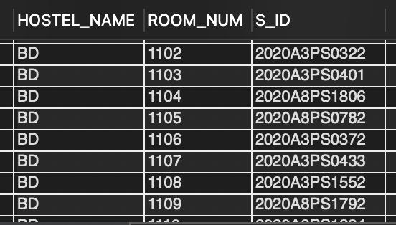

HOSTELS

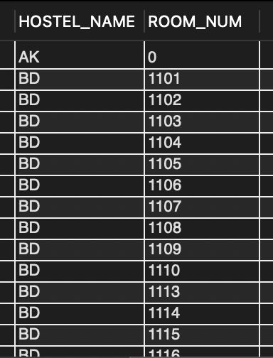

PHOTOS

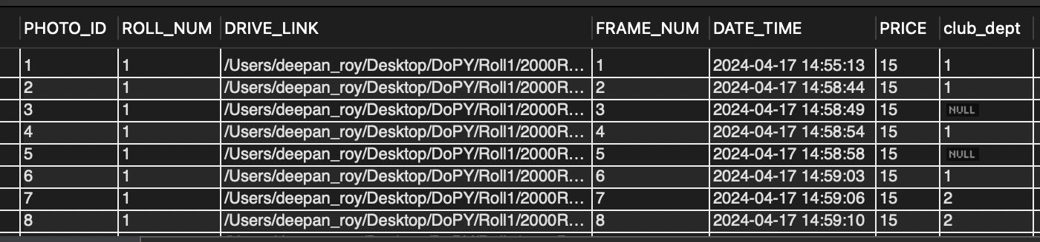

MEMBERSHIP

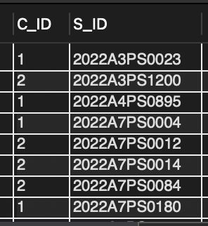

STUDENT

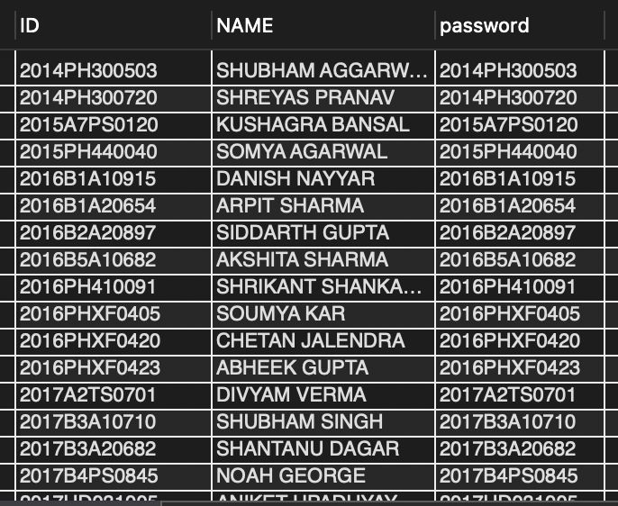

TAGGED_IN

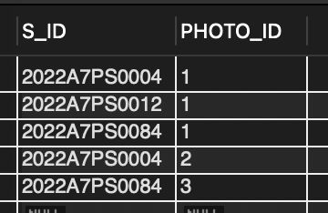

ADMIN



DELIVERIES

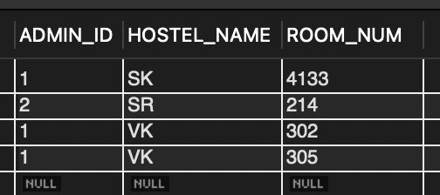

Complex queries:

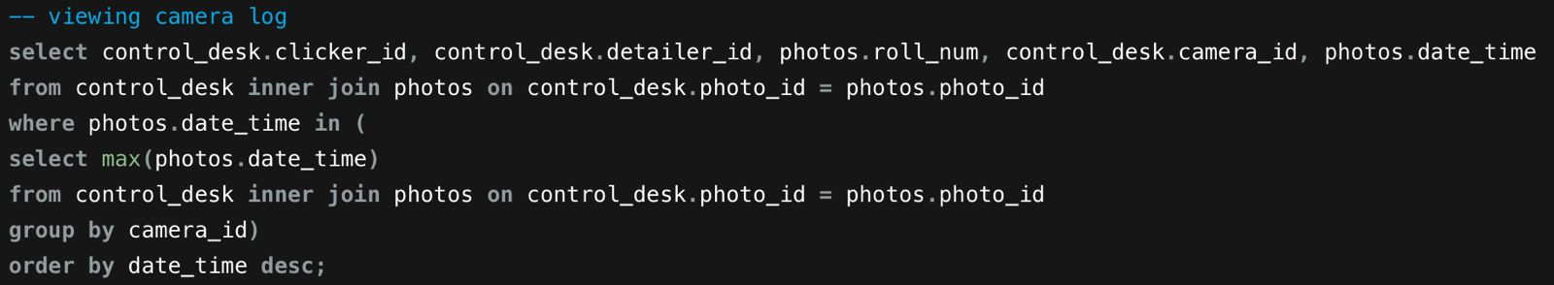

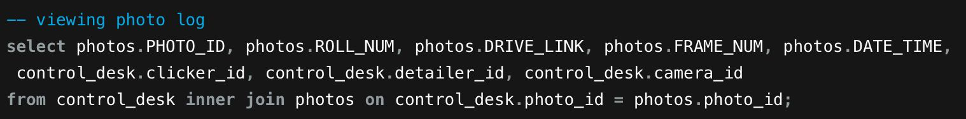

Inserting into tables:

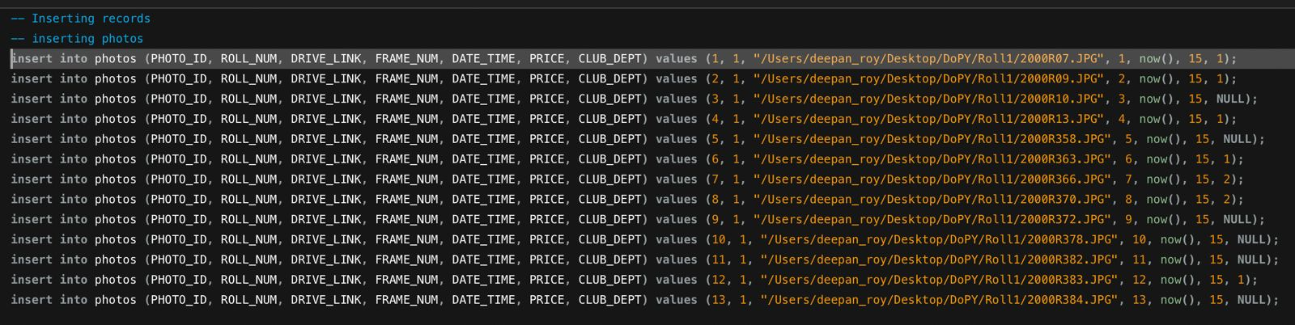

Creating tables: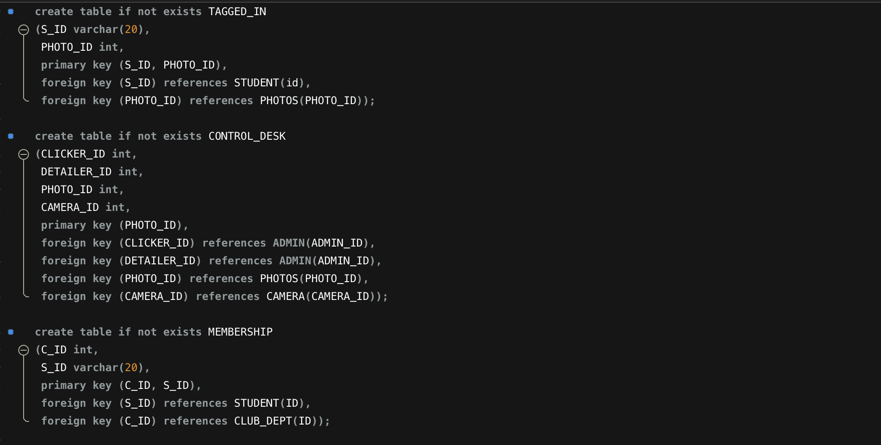

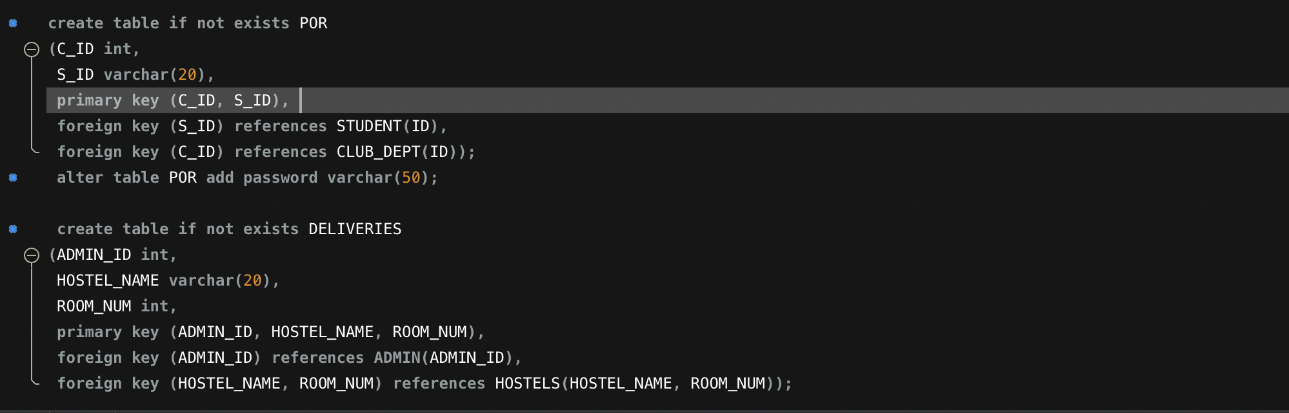

Initial Login Page

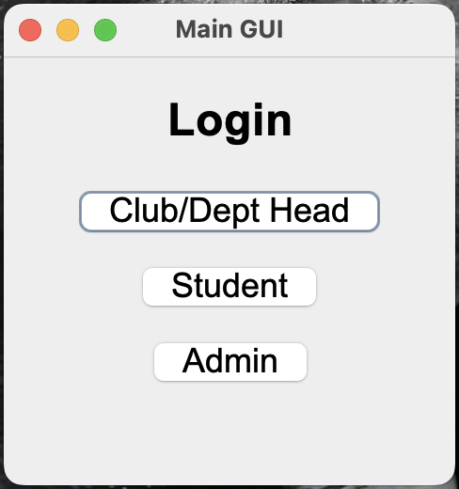

POR Login Page

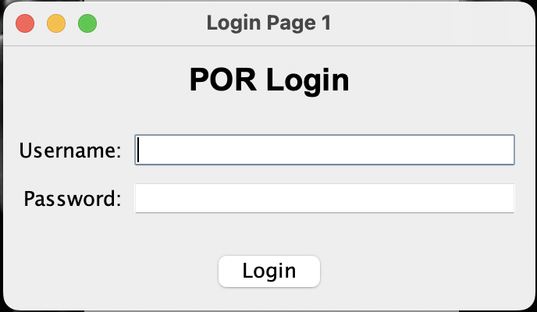

Failure to Log In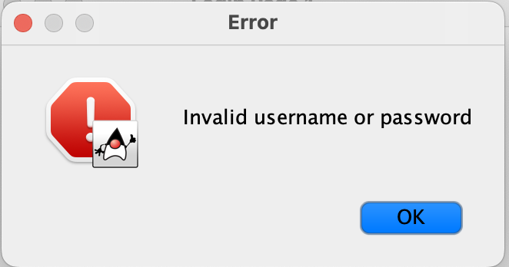

View Club and Dept Members

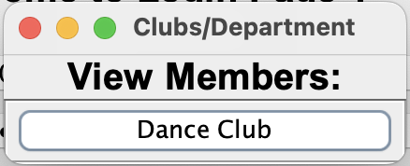

Member Details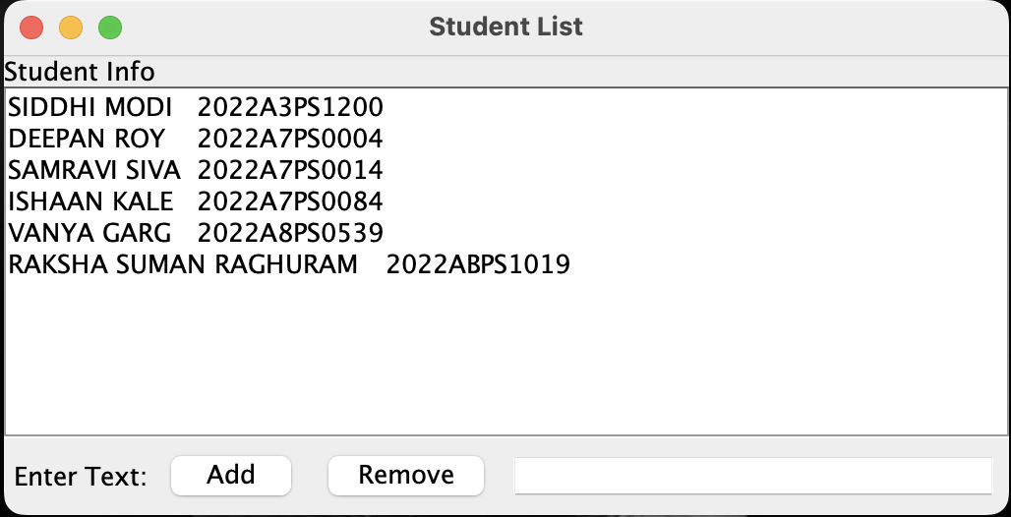

Add Member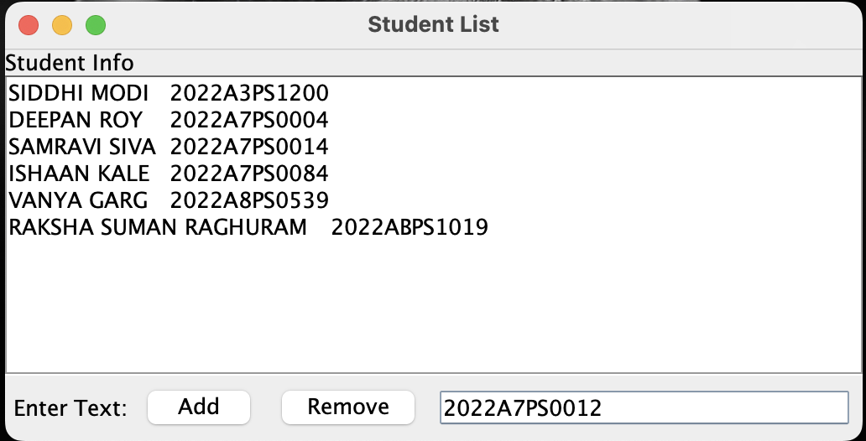Member Added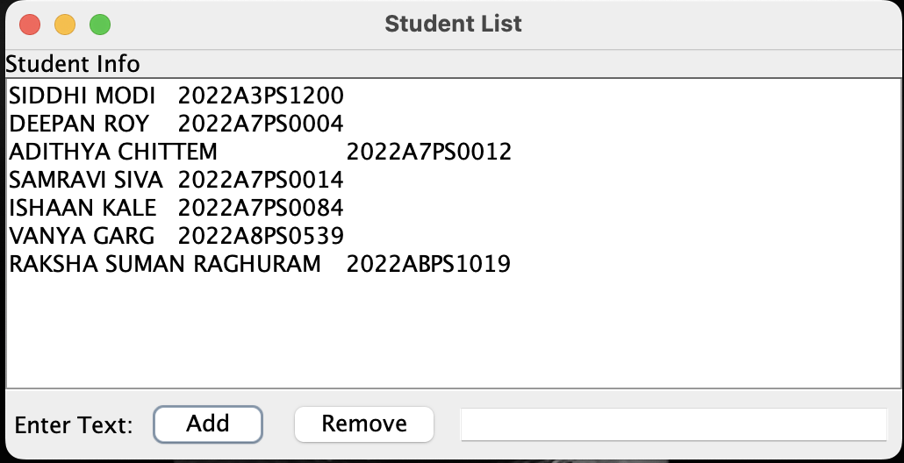

Remove Member

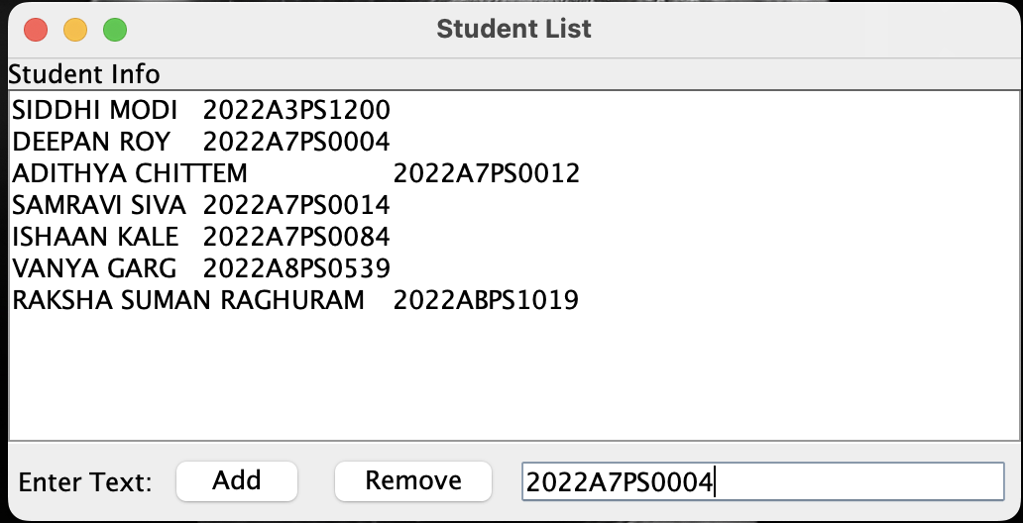Member Removed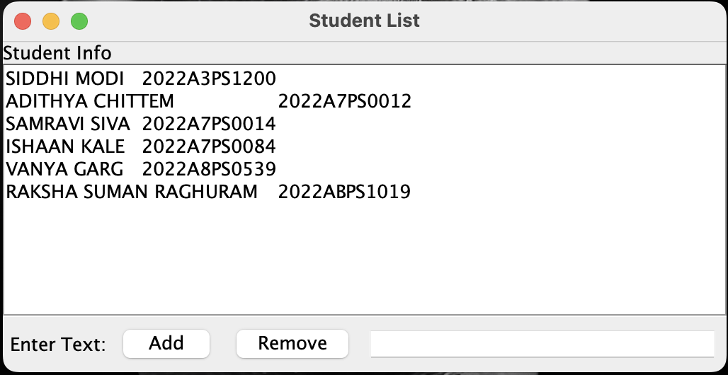

Student Login Page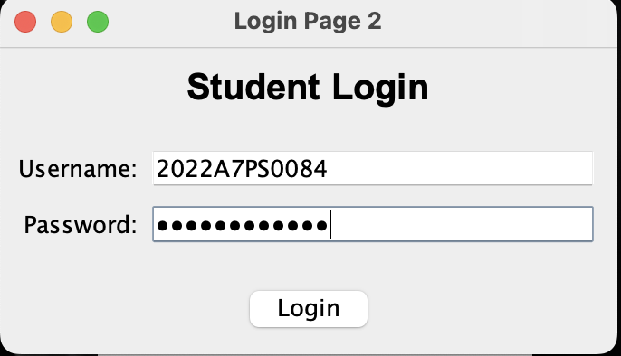Access Page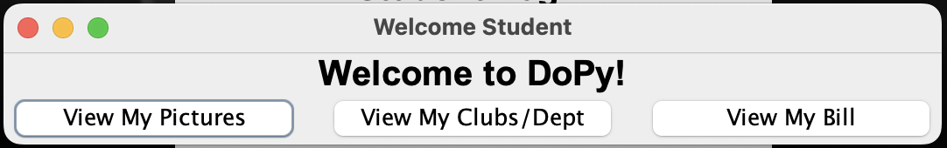

View Images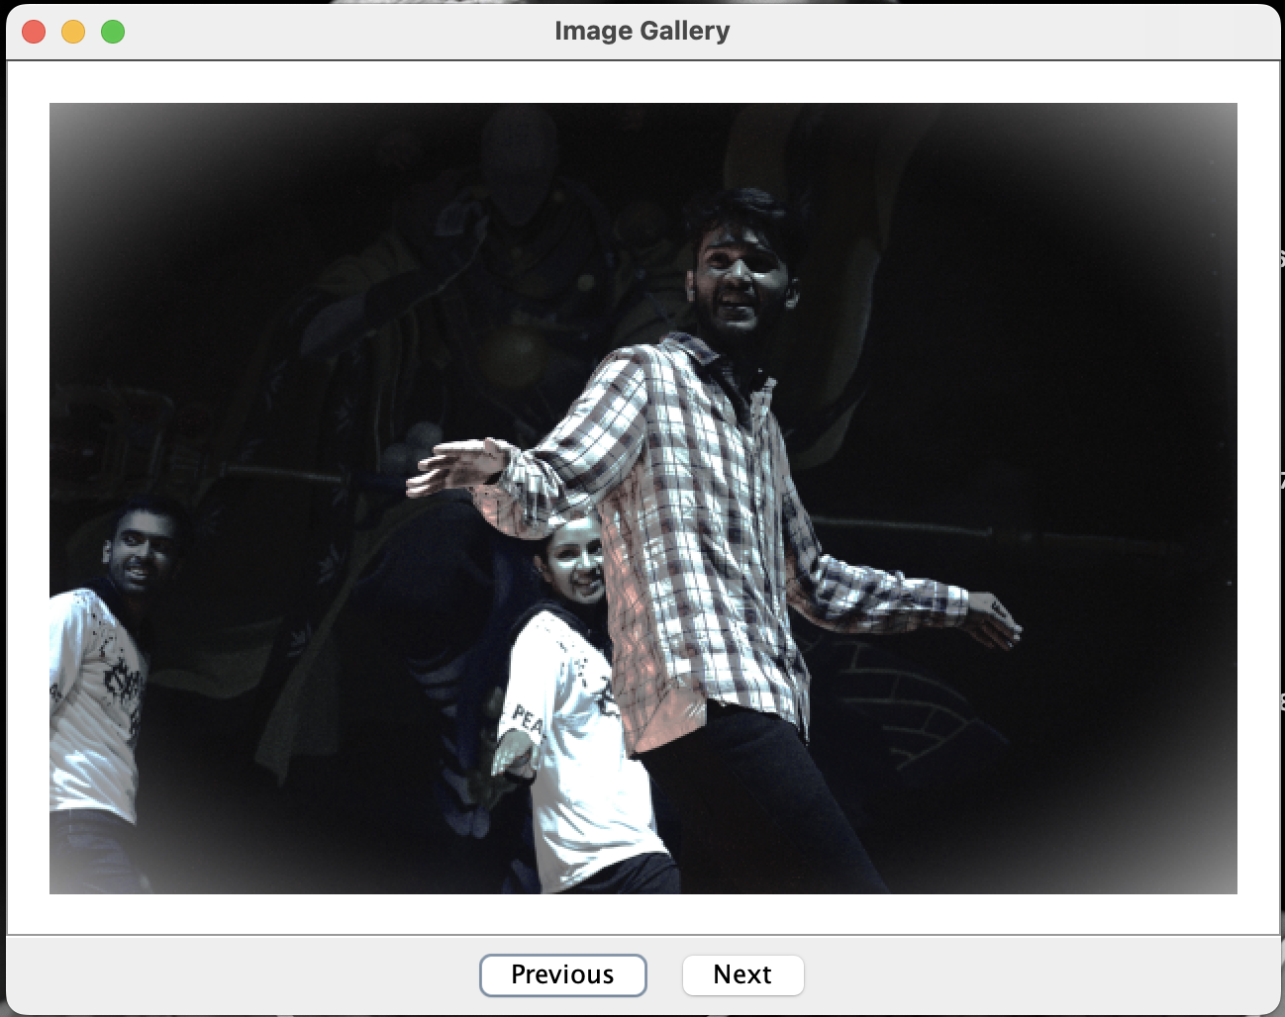

View Next Picture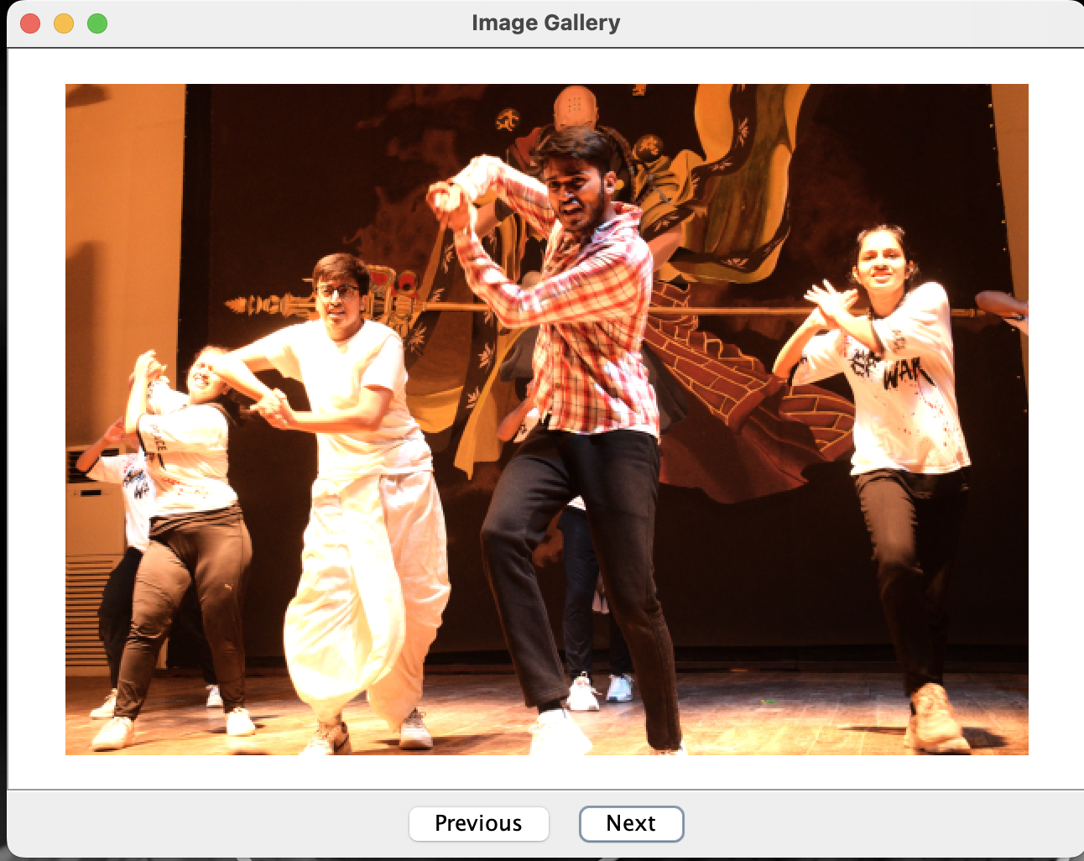

View Department Picture

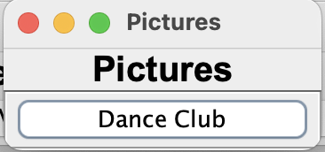

View Images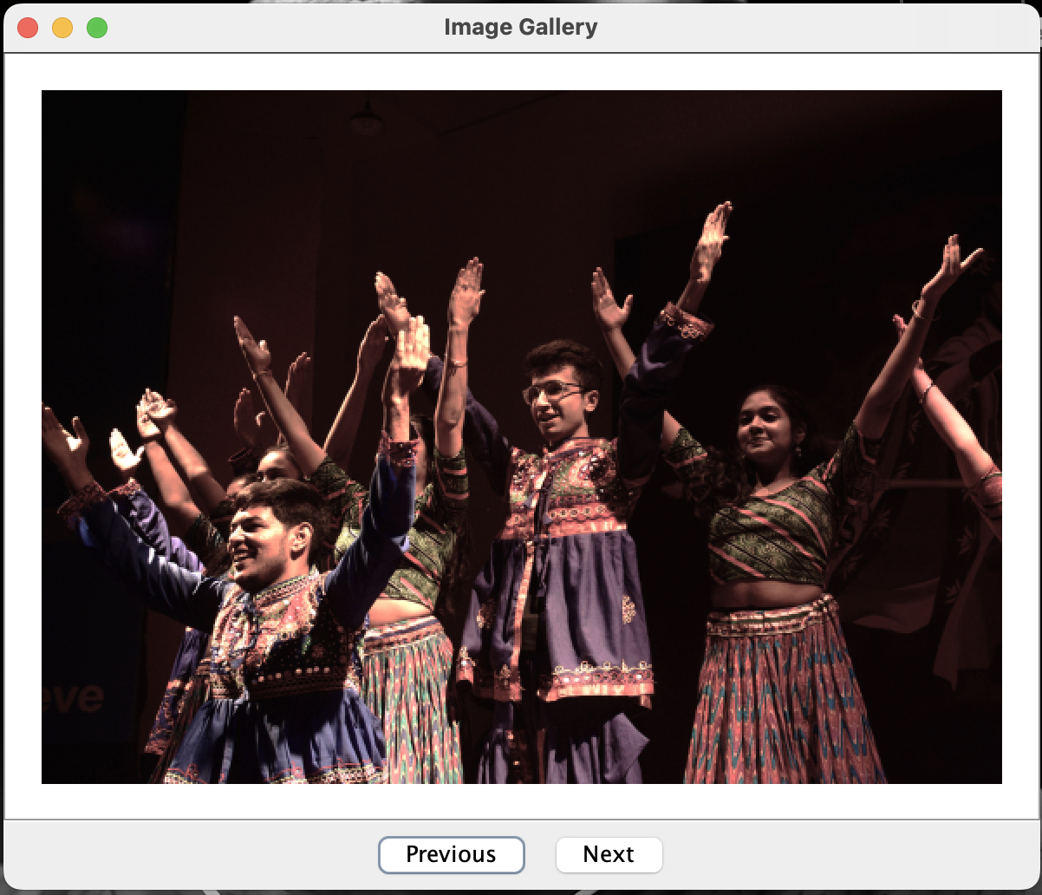P

Price Calculator Screens

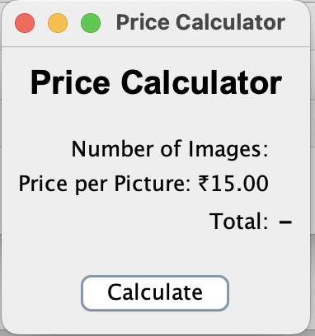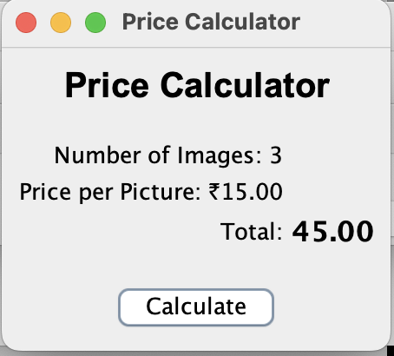

Admin Login and Access Screens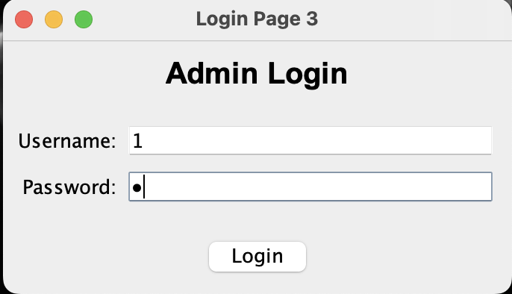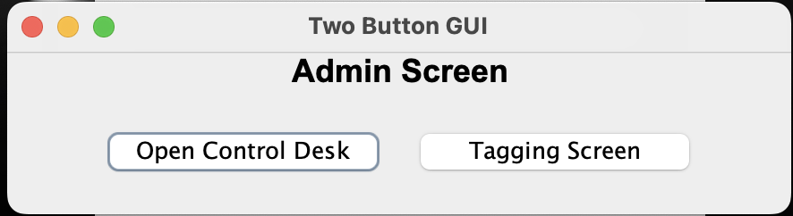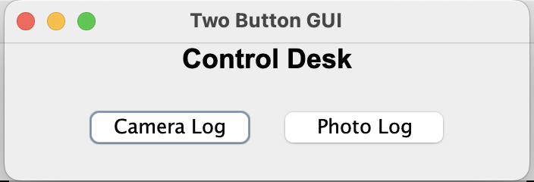

Camera Log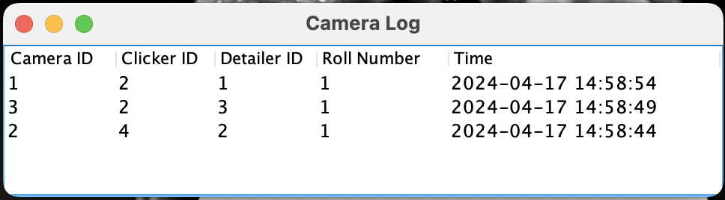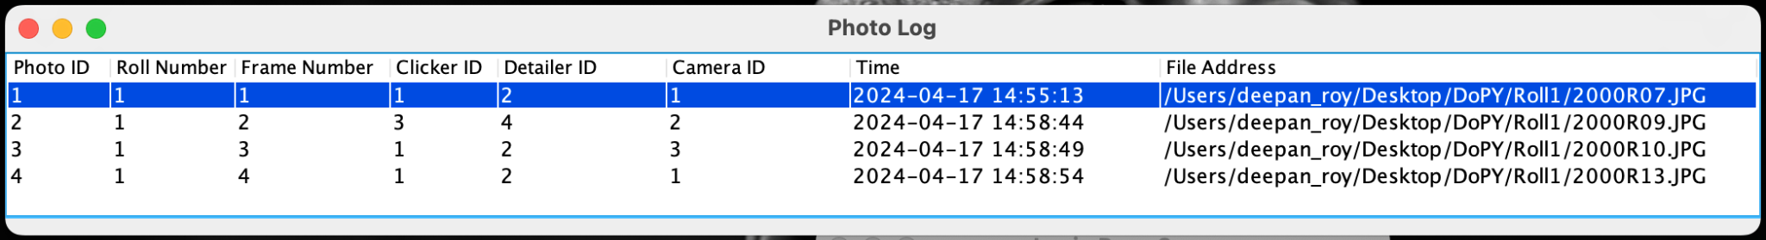

View Image and People Tagged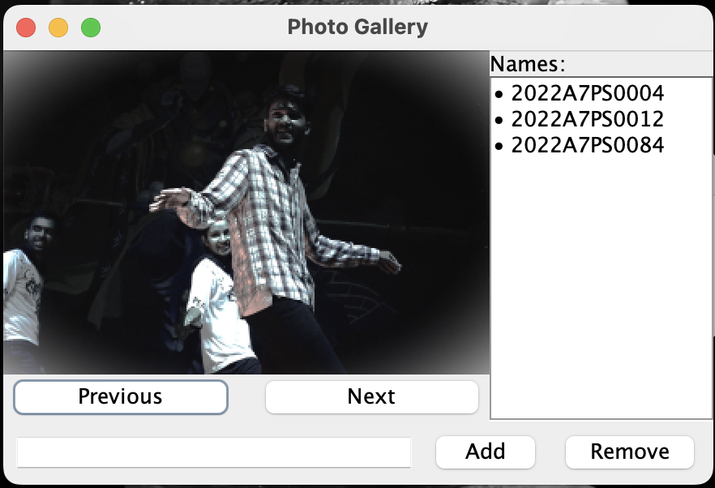

Tag Person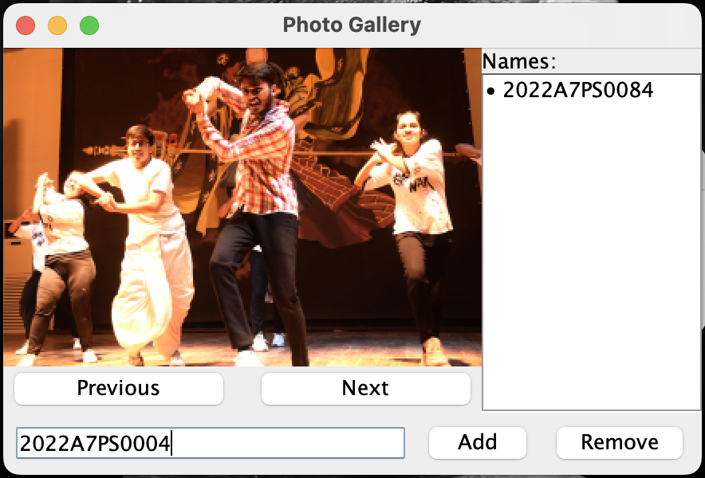

Person Tagged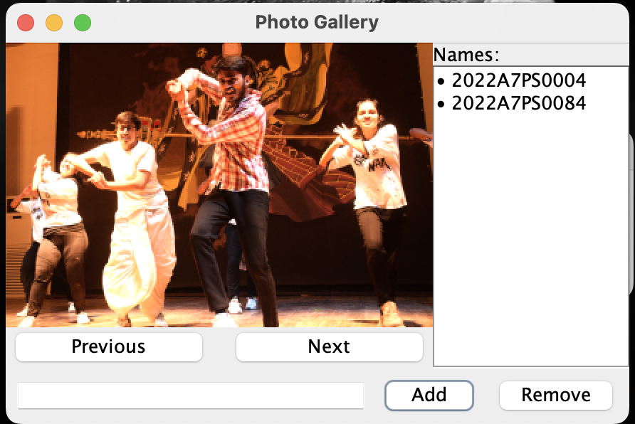

Remove Tag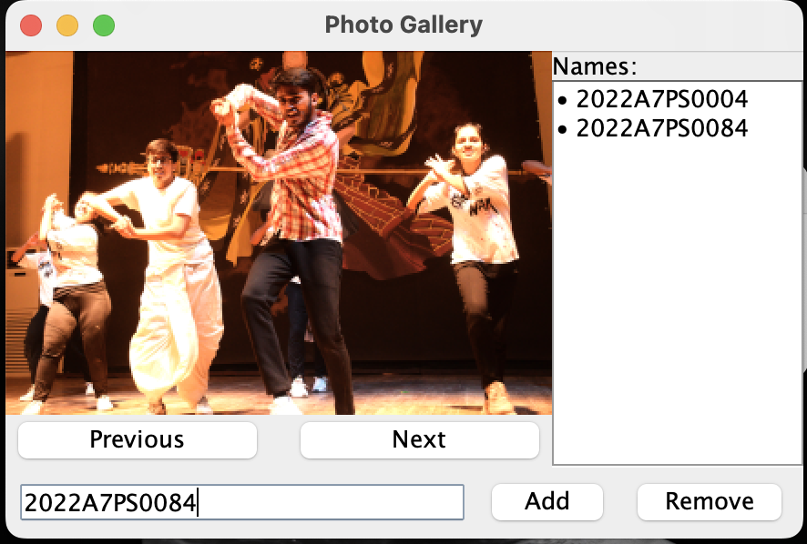Tag Removed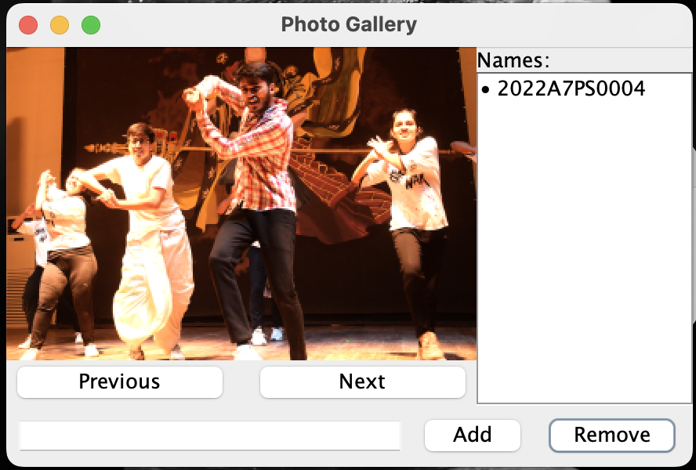

**Conclusions**

Developing the Department of Photography App taught us not only how to retrieve and manipulate data effectively but also gave us a real sense of how databases work in the real world. Firstly, developing the ER and Relational Models gave us a practical application of normalization concepts learnt in the classroom. Another highlight was utilizing SQL to manage our database efficiently as well as to implement complex queries to get the output that the user expects from the frontend. On the front-end side, working with Java Swing for the GUI taught us how to design interfaces that are not just functional but also user-friendly. Overall, this project helped us to apply the knowledge we had obtained in the classroom, to a real-life situation.